**Calculator Graphing Warm Up**

Let's play with our calculators a little bit as we talk about equations of lines:

Press ZOOM and choose 6:ZStandard.

Press Y= to see the screen where you enter equations.

Type in y1=2x-3. (Use the second key on the second row to get the x.)

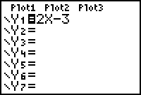

Press GRAPH to see the graph.



Cool! Now, see if you can match these calculator pictures. Write down the equations that you use.

y1=

y2=

y3=

y4=

y5=

y6=









Hint: Use the point-slope formula for a line:



where m = slope

and  = some point on the line